# **Phone Type Clean up**

### **Exporting Records**

Go to RE > Query > Personal – Axl Monreal > AM-PT-Cleanup.

Open AM-PT-Cleanup.

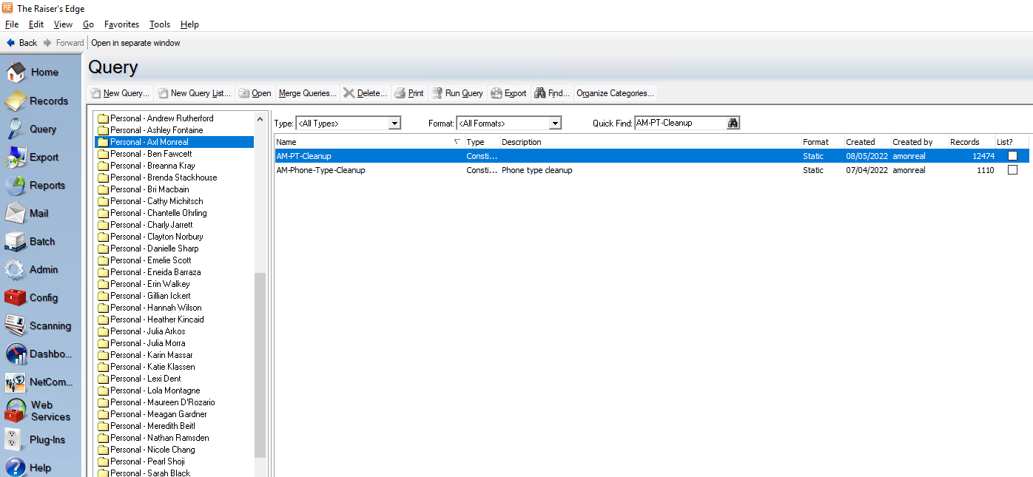

Click on the “+” icon and update the range of date to set one month.

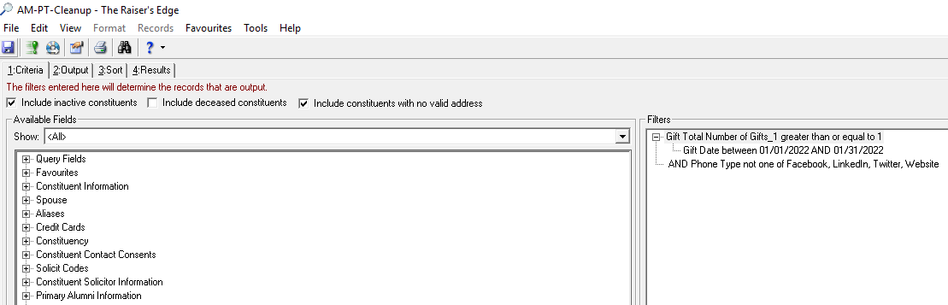

Save and close the query.

Go to Export > General > AM-Phone-Type-Cleanup-Export.

Open AM-Phone-Type-Cleanup-Export.

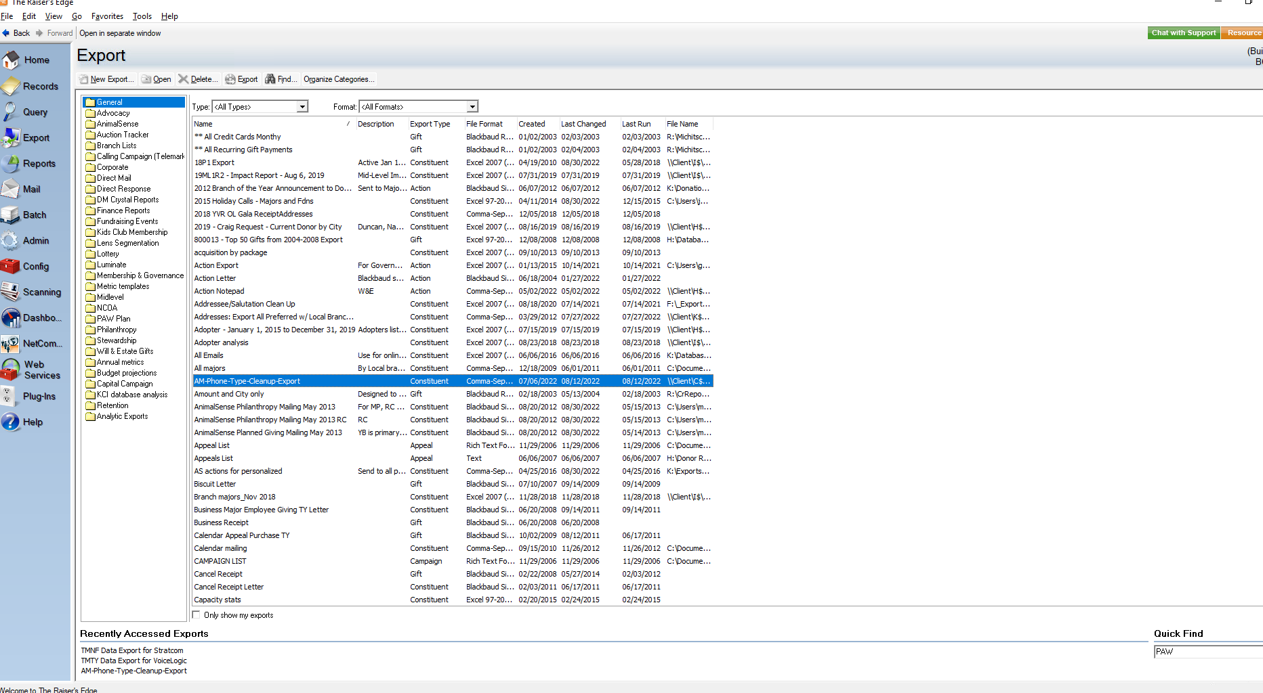

Make sure AM-PT-Cleanup query is included in the top of the screen.

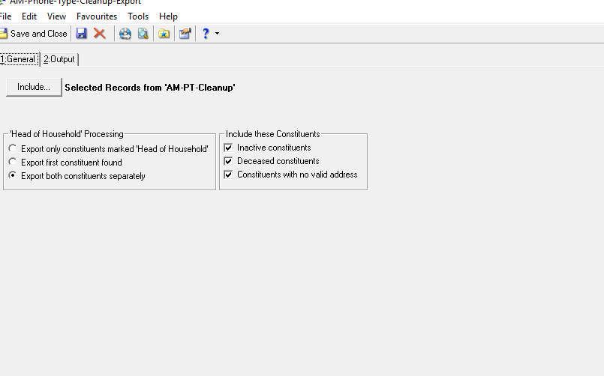

Click on Export Now.

Save it in K:\Database Manager Project\Database Projects\Phone Cleanup\RE – Original Export YYYYMMDD-(MM)DD.CSV. This will take a few of minutes.

**SPLIT FILE**

Open the “Phone Cleanup Worksheet” file saved in K:\Database Manager Project\Database Projects\Phone Cleanup\Original\

In the Original sheet (first sheet) select cell A1, right click to select Edit Text Import

Browse to find the file previous saved and click ‘Import’

Change File origin to 1252 : Western European (Windows)

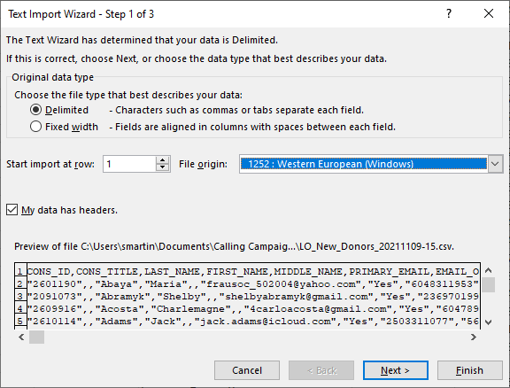

Click ‘Finish’

Save the file.

Copy all data from the Original sheet to the SettingPrimary sheet.

Make sure all "Last Update" and "Date Last Changed" cells are formatted as a date.

Filter “Type” column to show only Business # types and “Comments” column for blanks, then replace “Type” with Phone# and column “Comments “with “Is a business phone”.

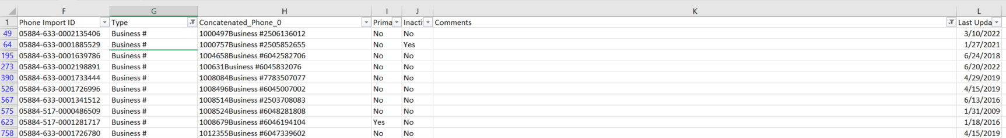

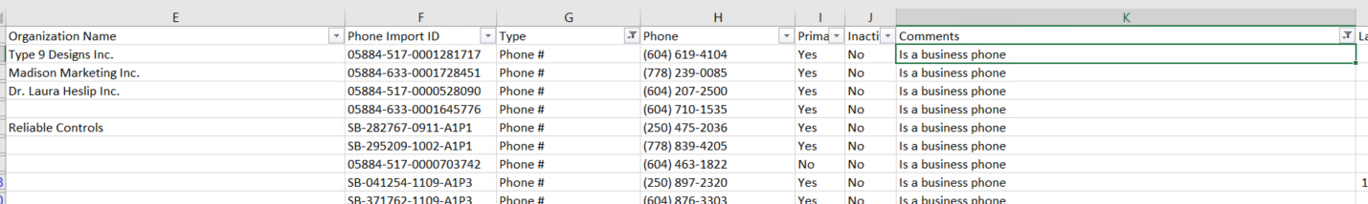

Remove filters and filter again “Type” column to show only Business # types, then replace “Type” with Phone# and in column “Comments “add “; Is a business phone” next to the current comment.

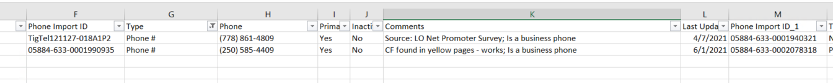

Filter column “Type” to show only “Direct #”, “Toll Free #” and “Other” types and replace it with Phone#.

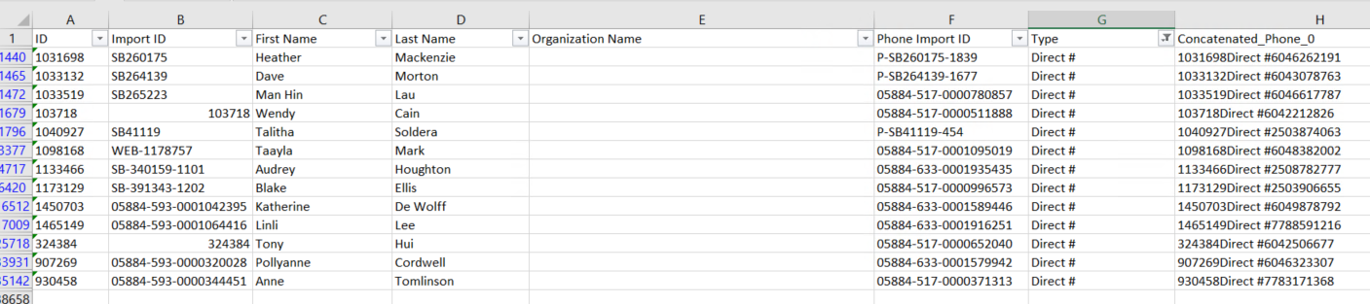

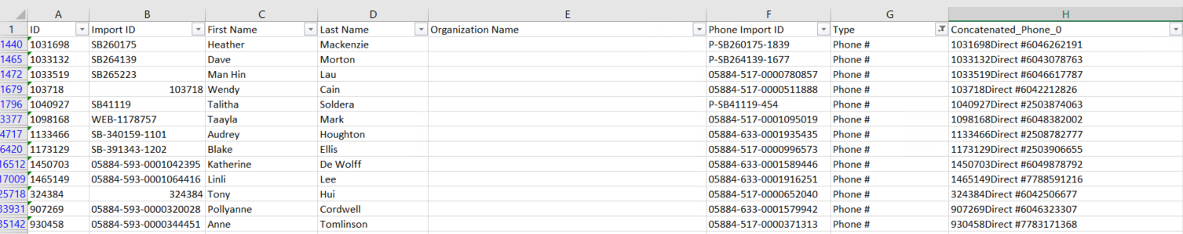

Filter column “Type” to show only “Number-Incomplete #”, “Number-Invalid”, “Number-Not In Service” and “Number-Wrong Number” types and mark those records as inactive.

Note: if the records are mark as a primary, then set them as a no primary.



Repeat steps XXX to XXX for each Type in columns N, U, AB, AI, AP, AW, BD, BK and BR.

Filter “BY” column to show only “Email-Business” # types and “Comments” column for blanks, then replace “BY” with “Email” and column “Comments “with “Is a business email”.

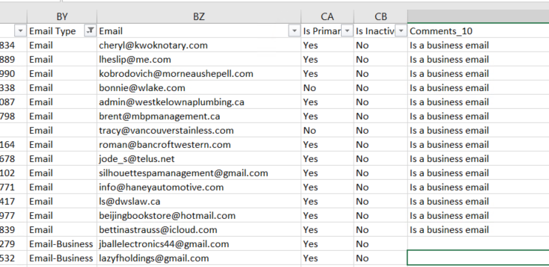

Remove filters and filter again “BY” column to show only Email-Business # types, then replace “Type” with “Email” and in column “Comments “add “; Is a business email” next to the current comment.

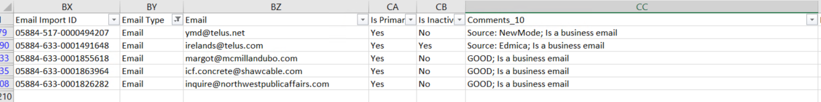

Filter column “BY” to show only “Email-Invalid” types and mark those records as inactive.

Note: if the records are mark as a primary, then set them as a no primary.

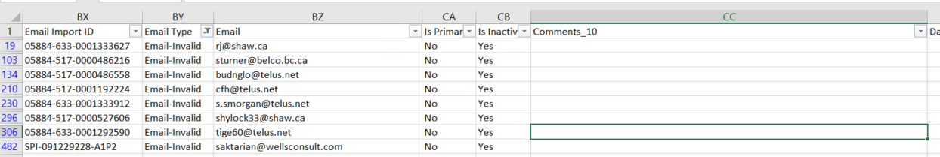

Repeat steps XXX to XXX for each Type in columns CF, CM, CT, DA, DH, DO, DV, EC and EJ.

Copy next formula in EP2 cell: =IF(OR(I2="Yes",P2="Yes",W2="Yes",AD2="Yes",AK2="Yes",AR2="Yes",AY2="Yes",BF2="Yes",BM2="Yes",BT2="Yes"),TRUE,FALSE).

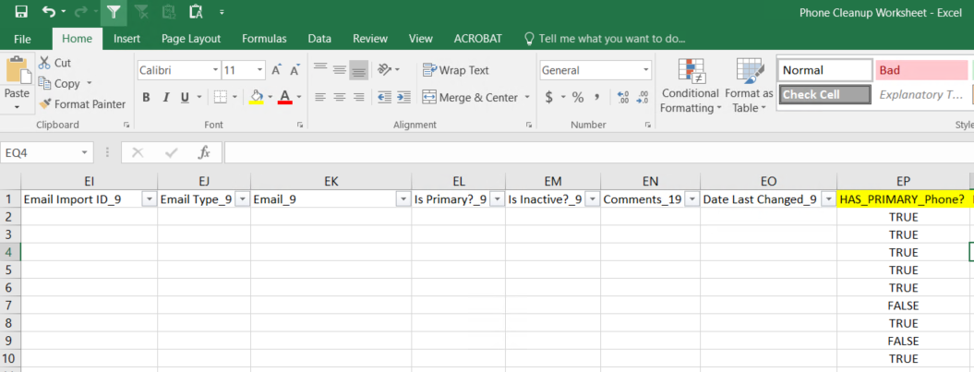

Drag and drop the formula in the "EP" cell to the number of records you are working on.

Filter HAS_PRIMARY? (EP) column to show only "FALSE" records.

Copy next formula: *=IF(ISBLANK(I#),"",MATCH(MAX(IF(J#:BU#="No",L#:BW#)),L#:BW#,0)+8)* and press **Ctrl + Shift + Enter** on “EQ” column and substitute # for the number of the first row displayed.

Copy next formula: *=IF(ISBLANK(EQ#),"",ADDRESS(ROW(),EQ#))* on “ER” column and substitute # for the number of the first row displayed.

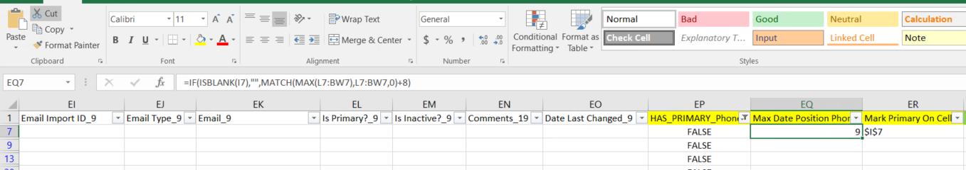

Drag and drop "EQ" and "ER" Columns until last row displayed.

Filter for each "Max Date Position"(EQ column) excluding ***“#N/A”*** (because this are records with all phone numbers mark as inactive), and use the "ER" column to mark as a primary ("Yes").

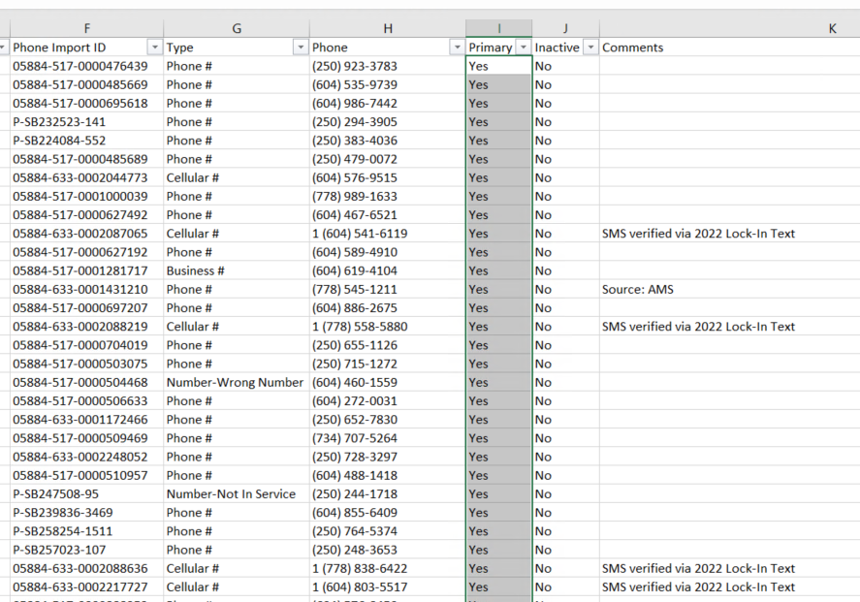

**Note:** Before update the Primary status, check the Inactive column to make sure all values are “No”, if you find some “Yes” values ***(probably is the same last update date)***, check and choose the primary record based on the last update date.

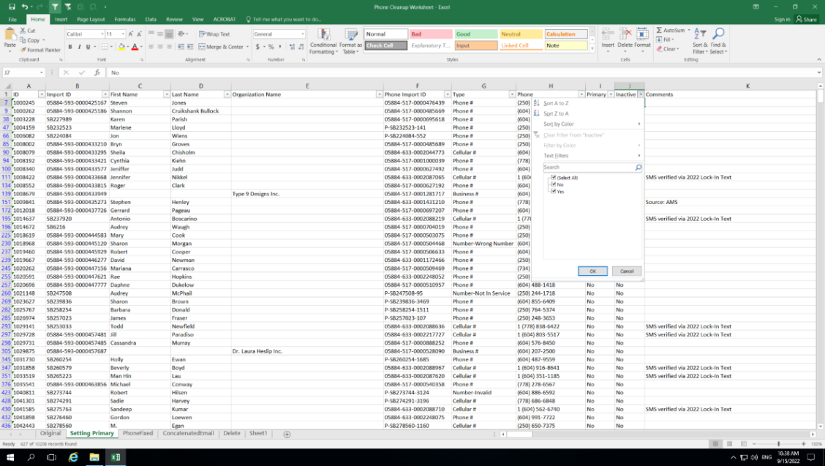

Also make sure is a valid Phone number.

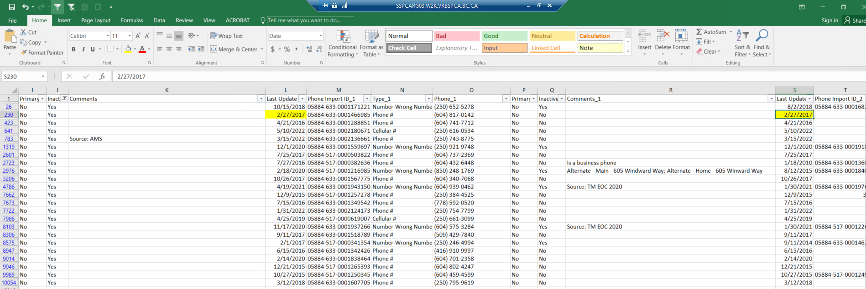

Confirm that the "EP" Column now shows only "TRUE" for the phone numbers that you updated in the previous step.

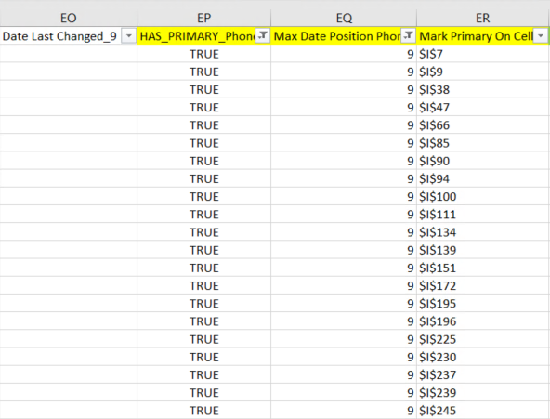

Repeat steps 4xx to 7xx with "ES", "ET" and "EU" columns to set as a primary email.

Formulas:

* ES:=IF(OR(CA2="Yes",CH2="Yes",CO2="Yes",CV2="Yes",DC2="Yes",DJ2="Yes",DQ2="Yes",DX2="Yes",EE2="Yes",EL2="Yes"),TRUE,FALSE).
* ET: =IF(ISBLANK(CA#),"",MATCH(MAX(IF(CB#:EM#="No",CD#:EO#)),CD#:EO#,0)+78) and **press Ctrl + Shift + Enter.**
* EU: =IF(ISBLANK(ET#),"",ADDRESS(ROW(),ET#)).

Go to PhoneFixed sheet and make sure formula in row 2 is working. Then drag and drop for the same number of rows that are in Original sheet.

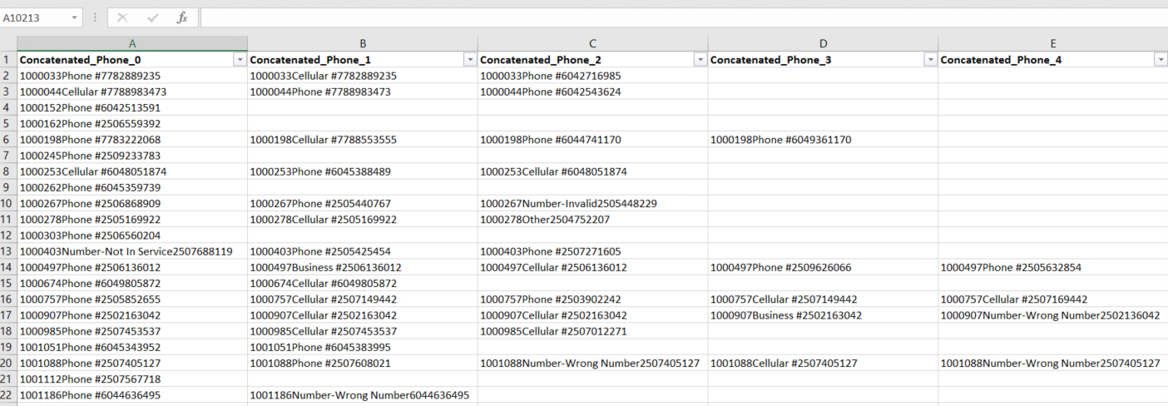

Filter for *“#VALUE!”* in each column, then check into the Original sheet if has a value there. Most of the cases is because an email address are in the Original sheet instead a phone number or are blank cells.

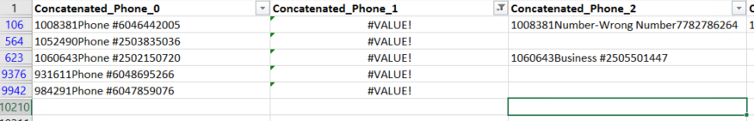

If is an empty cell in the Original sheet, replace *“#VALUE!”* With blank in the PhoneFixed sheet.

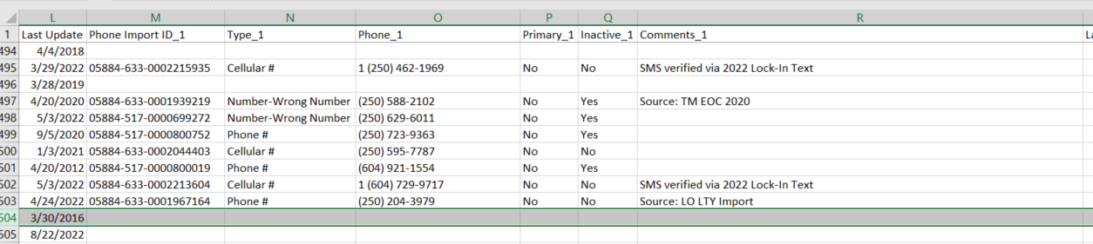

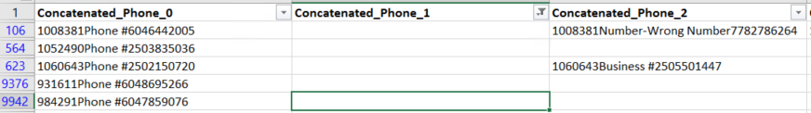

Otherwise copy the ID and the phone to the Fix After Import sheet, then in the Original sheet, replace *“#VALUE!”* With blank in the PhoneFixed sheet.

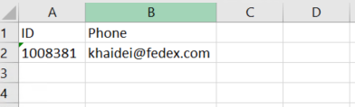

Copy Data from Column A to EO from “SettingPrimary” to “Data” sheet.

Substitute every phone number with the corresponding concatenated phone on the “Data” sheet. Example Phone on “Data” sheet **"H"** column needs to be replaced with **"A"** column from PhoneFixed sheet.

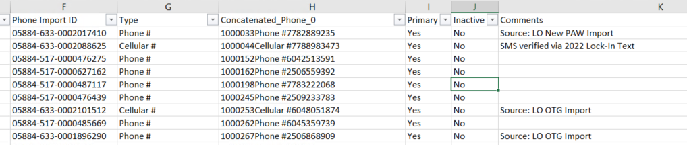

Go to ConcatenatedEmail sheet and repeat steps 111XX to 22XXX, using email cells this time.

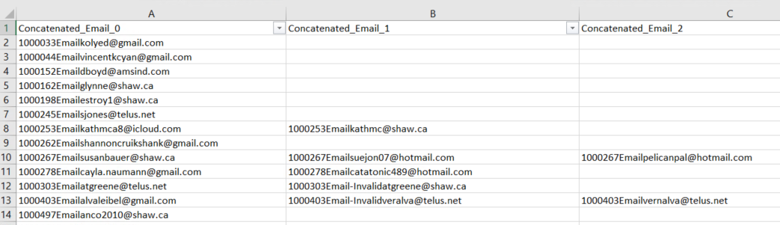

Go to the TypeFixed sheet and make sure that “TypeFixed” column doesn’t exists, if is there just delete it.

Copy from “Data” sheet from column "A1" to "L#".

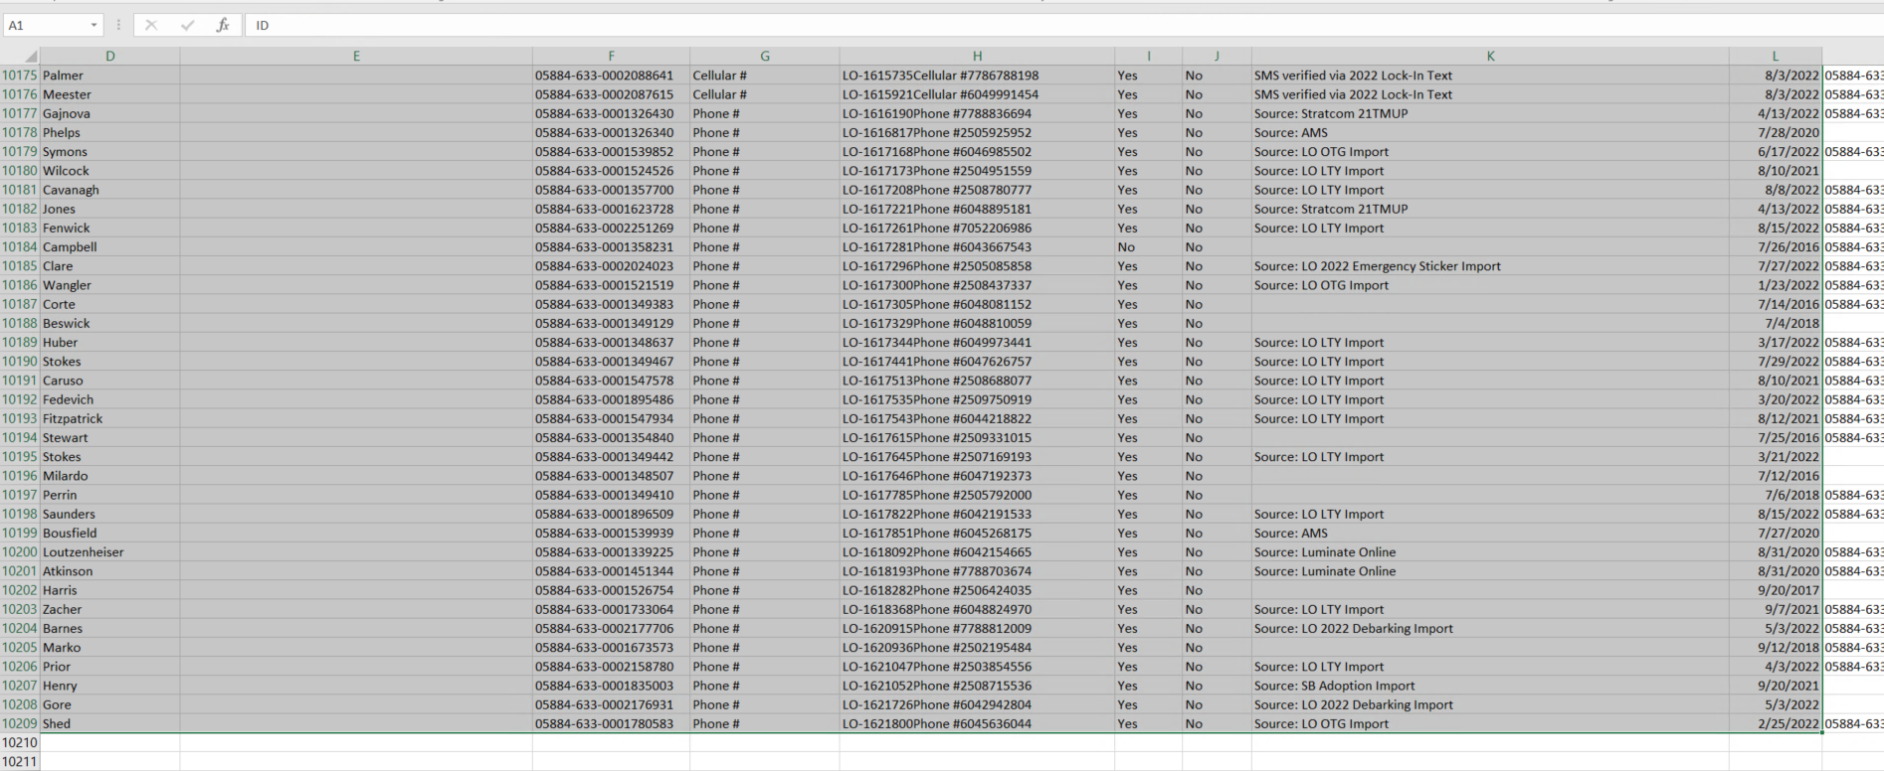

Paste values on TypeFixed sheet cell A2.

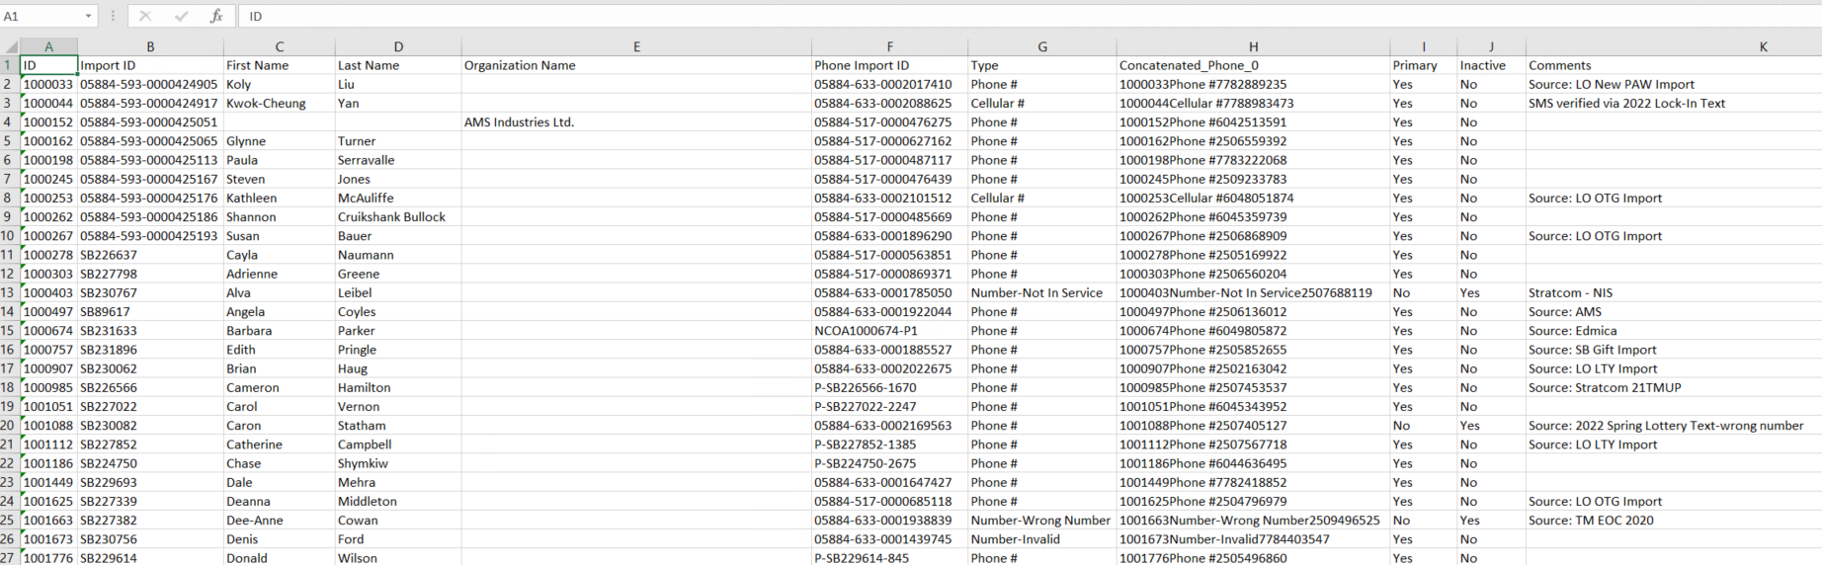

Filter column "H" for blanks and delete showing records.

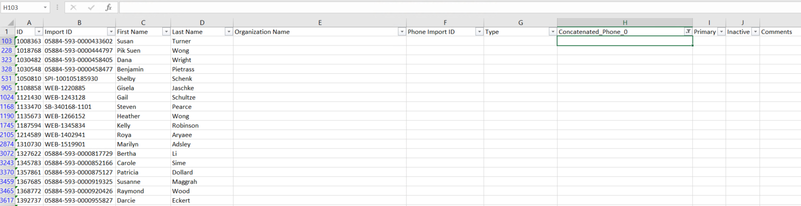

Remove filters and go the next blank available cell in column A.

Delete column "F" to "L" on the Data sheet.

Repeat steps 10XX to 12XXX for each phone number and email address.

Copy TypeFixed sheet into Import WorkSheet file

Insert a new column after Type (column G) and call it "TypeFixed ".

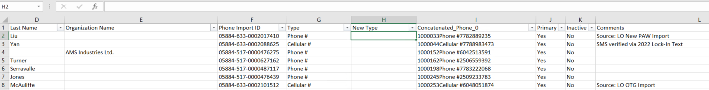

Sort column "A" in ascending order (*This can take some time*).

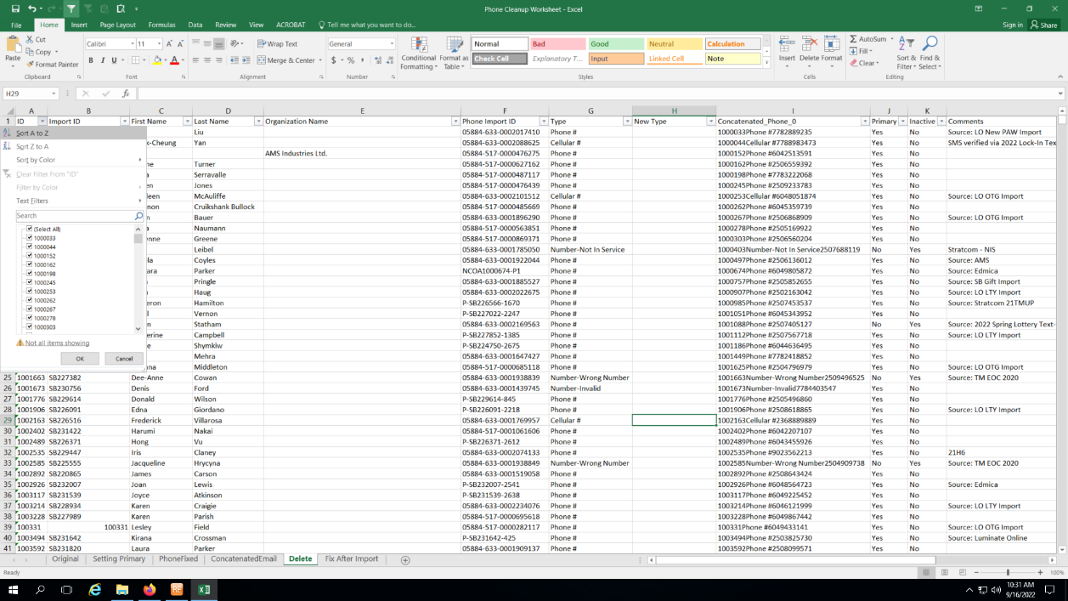

Copy next formula: =IF(COUNTIF($I$2:$I2,I2)>1,"Delete",G2) in "H" column, then drag and drop until the end.

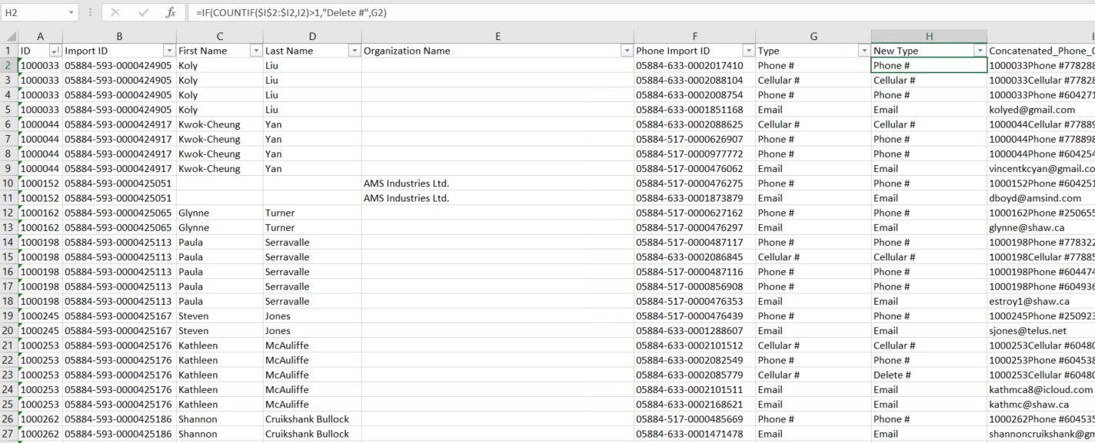

Filter by duplicates in column "I" to show only pink ones to double-check new types.

**NOTE:** Change to “Delete-Email” where column “I” is a email address.

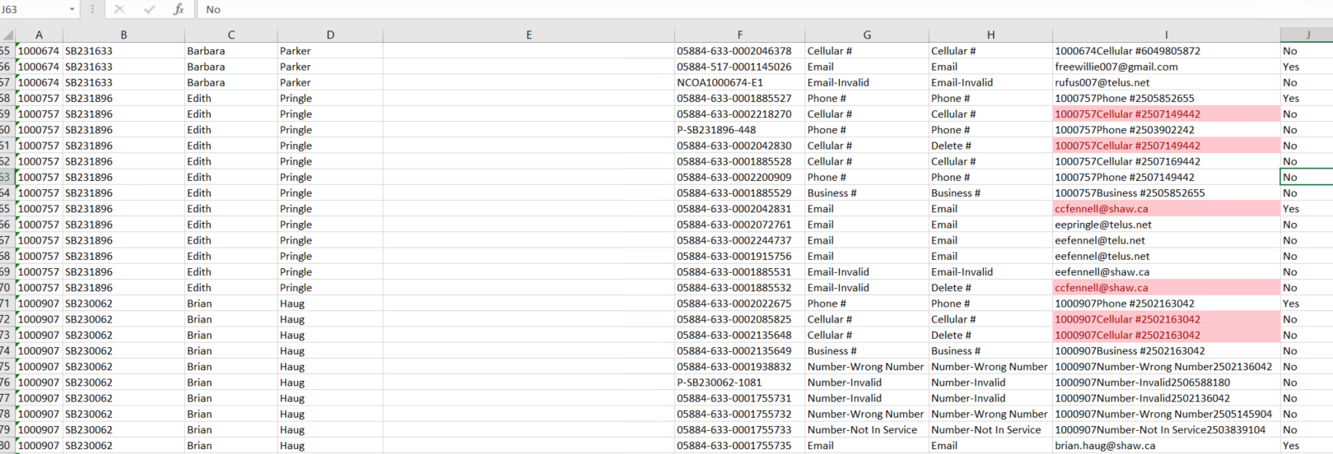

Remove filter from “I” column.

Copy values from column H and paste into column G.

Delete column H.

Recovering Original Phones/Emails.

Fixing Comments.

Order column “I” in Descending order, then order column “A” in descending order too.

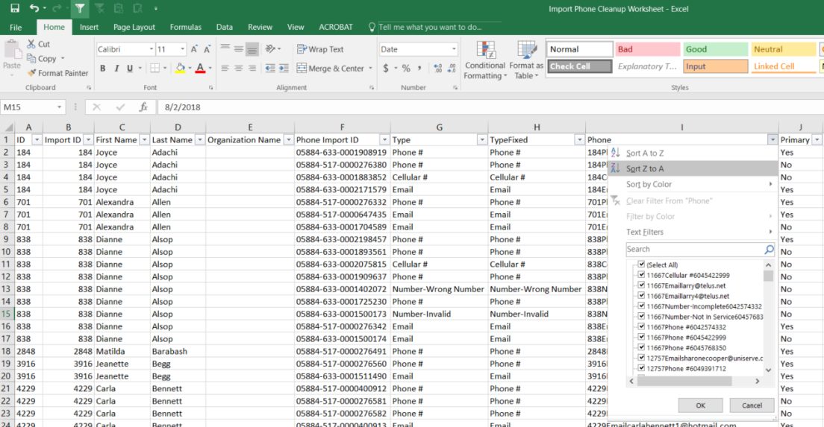

Add a new column next to Original Phone/Email and call it “Help”.

Fill column “Help” with number from 1 to the end of your data.

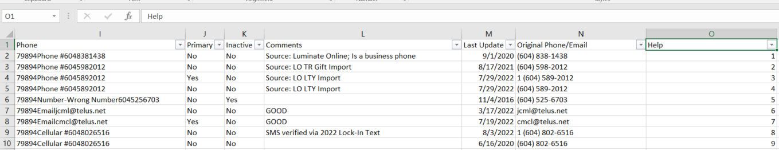

Order “Help” column in descending order. Then order Column A in descending order too.

Add a new column and call it “Fix Comments”.

Filter for duplicates only (pink)

In “Fix Comments”2 row paste next formula: =IF(I2=I1,K1&","&K2,K2), then drag and drop until the end of the file.

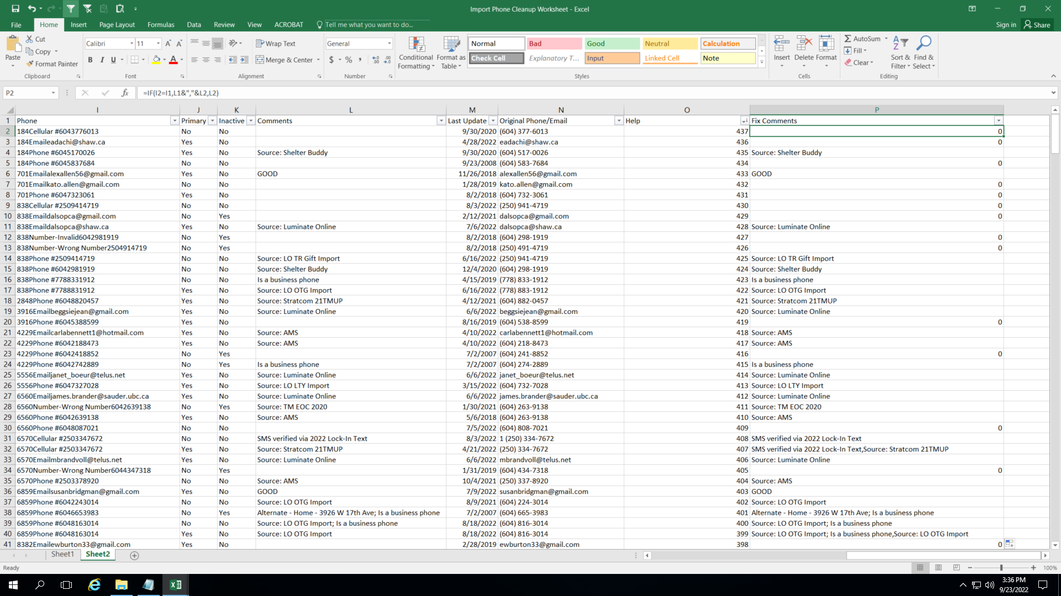

Filter column “Fix Comments” for “0”, “,” and “UNKNOWN”, then delete the displayed values on the same column.

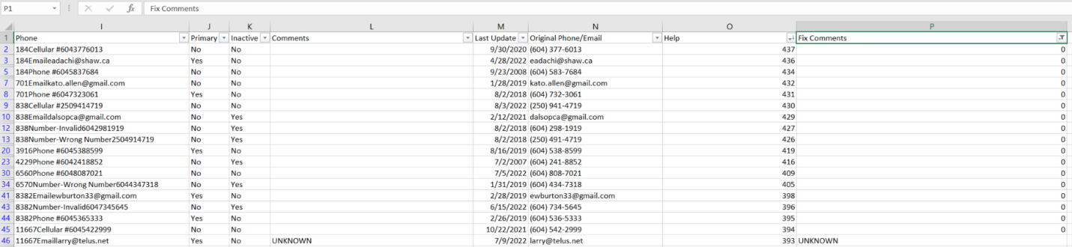

Clear filters.

Filter by duplicates in column "I" to show only duplicates.

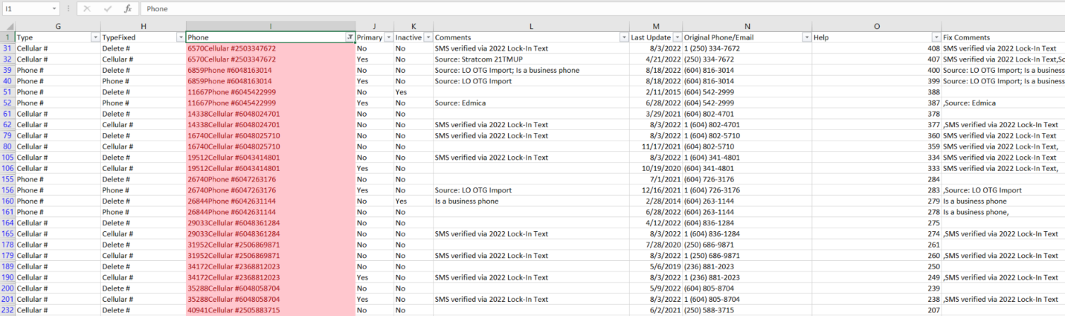

Add filters to column “Fix Comments” to highlight “Unique” values.

Look for duplicate text on “Fixed Columns” and fixed if is the same phone/email.

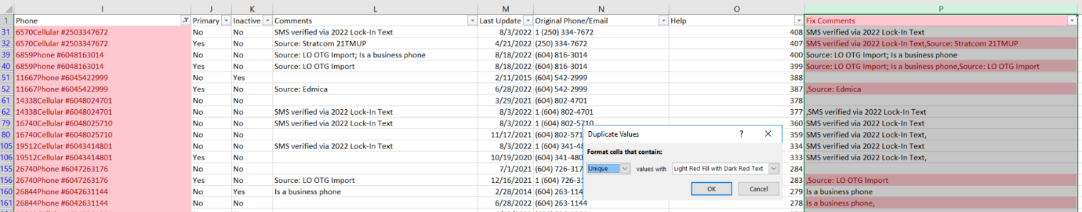

Replace “Comments” column values with “Fix Comments” values.

Delete “Help” and “Fix Comments” columns.

Save the file.

Save again as CSV file.

Preparing the import

Go to RE > Administration > Import > Constituent Phone.

Open the “AM-Phone Type Cleanup” profile.

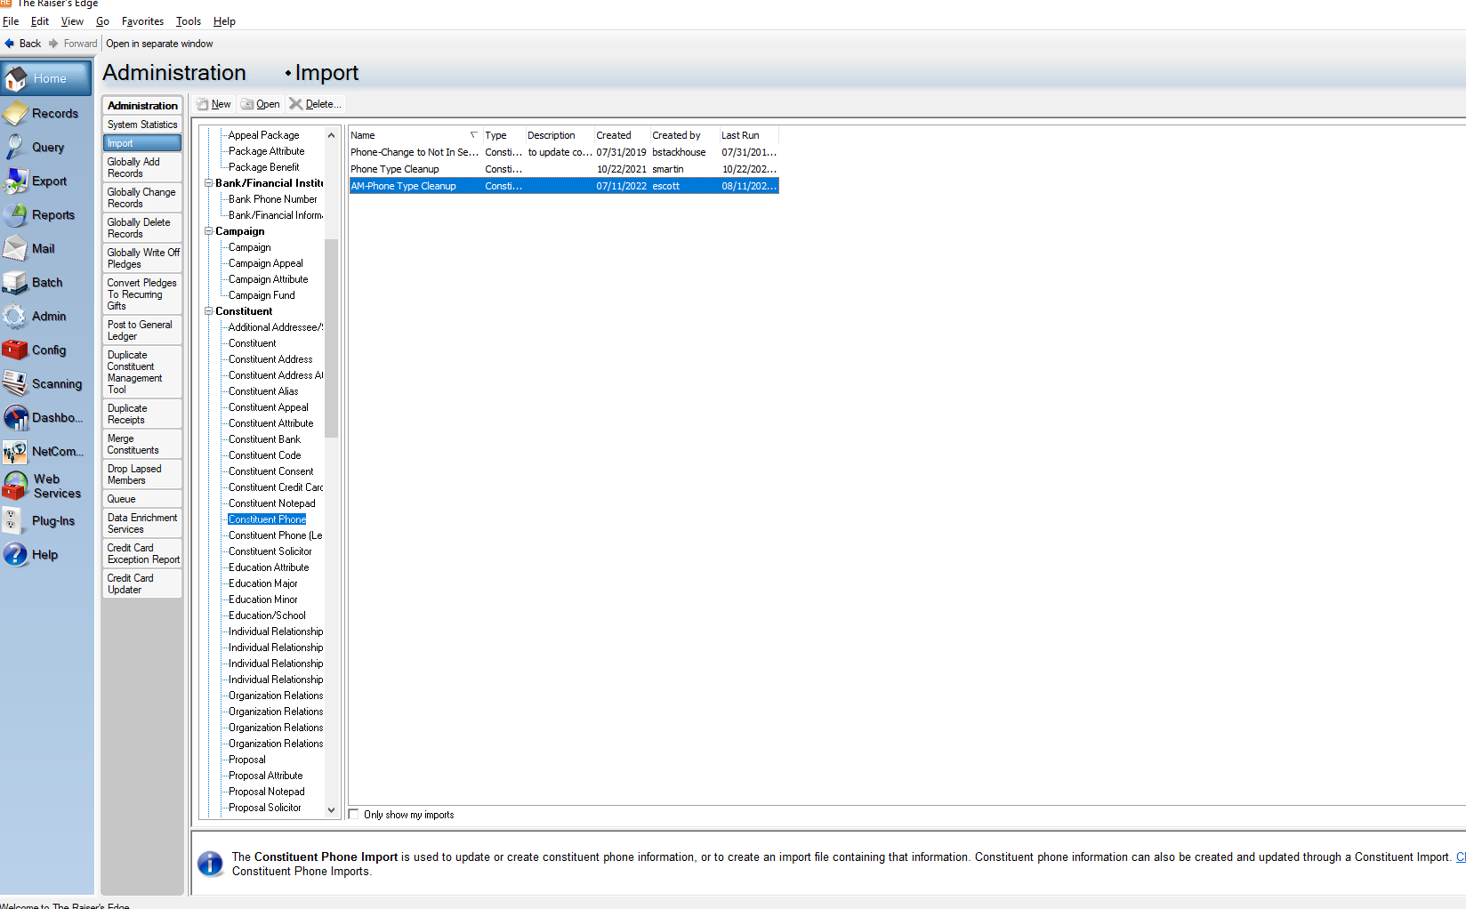

Click on the 3 ellipses and select the file you want to import. (Example: Cleanup part 1.csv)

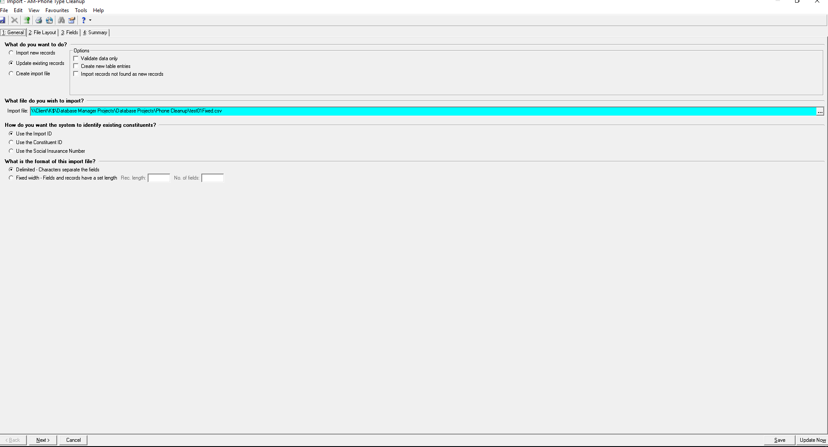

Go to the summary tab and add and “X” before the extension name of the file previously selected.

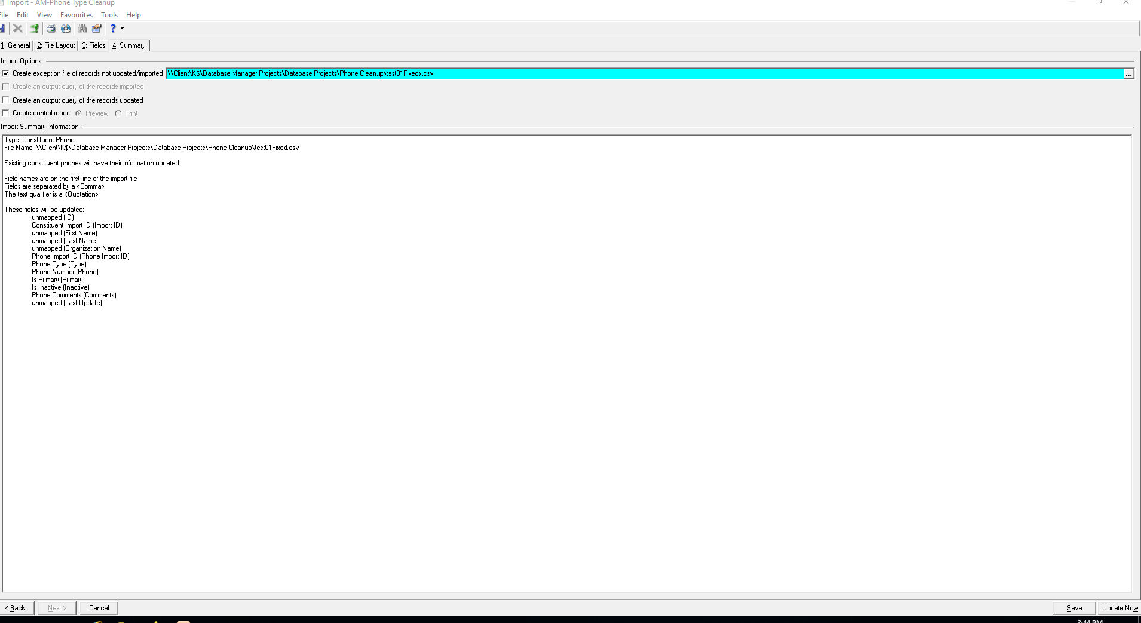

Click on Update now in the button right of the screen.

EXCEPTIONS

